CASE STUDY 3

# ORACLE – SQL

1. Display the subject code, subjects and total marks for every student. total marks is calculated as (s1+s2+s3...)

QUERY: SELECT STUDENT_CODE, SUBJECT1+SUBJECT2+SUBJECT3 AS TOTAL FROM STUDENT_MARKS;

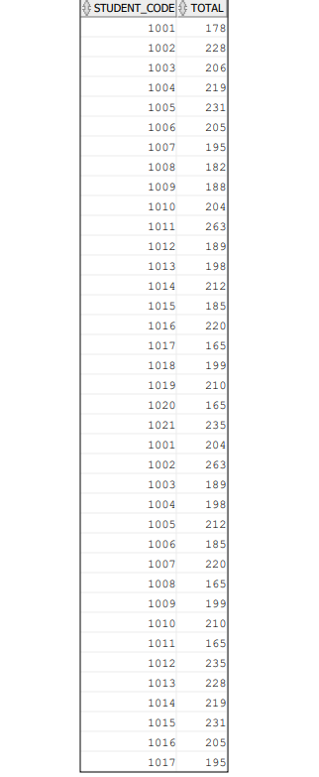

1. List the name and designations of the staff who have joined before Jan 2005.

QUERY: SELECT ENAME ,JOB FROM EMP WHERE hiredate <'01-JAN-2005';

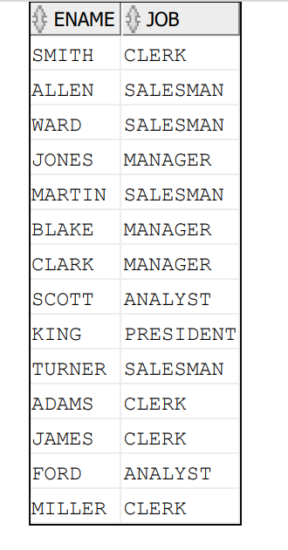

3. Display the employees for whom the manager is not allocated.

QUERY: SELECT ENAME FROM EMP WHERE MGR IS NULL;

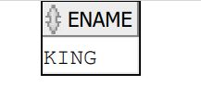

4. Display the details of the books that is not been returned and expected return date was monday.

QUERY: SELECT * FROM book_transactions WHERE book_expected_return_date != book_actual_return_date OR TO_CHAR(BOOK_EXPECTED_RETURN_DATE,'DAY')='MONDAY';

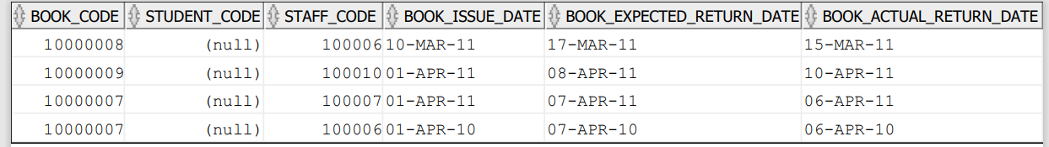

5. Check the date of birth of the students and display only those students who were born on saturday or sunday.

QUERY: SELECT STUDENT_NAME FROM student_master WHERE TO_CHAR(STUDENT_DOB,'FMDAY')='SATURDAY' OR TO_CHAR(STUDENT_DOB,'FMDAY')='SUNDAY';

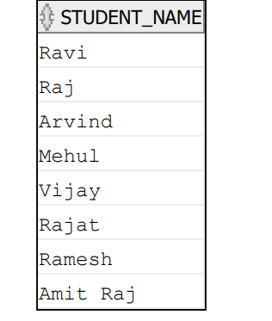

6. Display the staff name and hire date (through this date find out the day!).create a new column as DAY in the result nd sort it to start from monday.

QUERY: SELECT STAFF_NAME, HIREDATE,TO_CHAR(HIREDATE, 'FMDAY') AS "DAY"

FROM STAFF_MASTER ORDER BY(NEXT_DAY(HIREDATE, 'MONDAY') - HIREDATE) DESC;

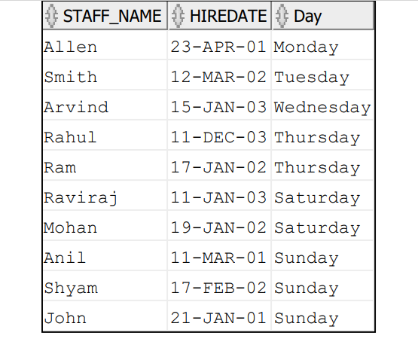

7. Display manager name, manager code and salary of the lowest paid staff in that manager's group.Exclude that group where the salary is less then 10k. Display other records in desc order.

QUERY: SELECT MGR, SAL,ENAME FROM EMP WHERE MGR IS NOT NULL AND SAL>1000

GROUP BY MGR,SAL,ENAME ORDER BY SAL DESC;

